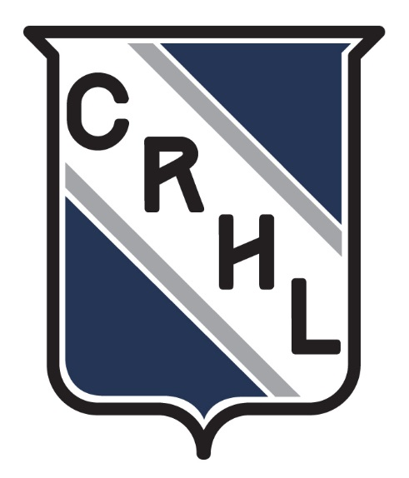

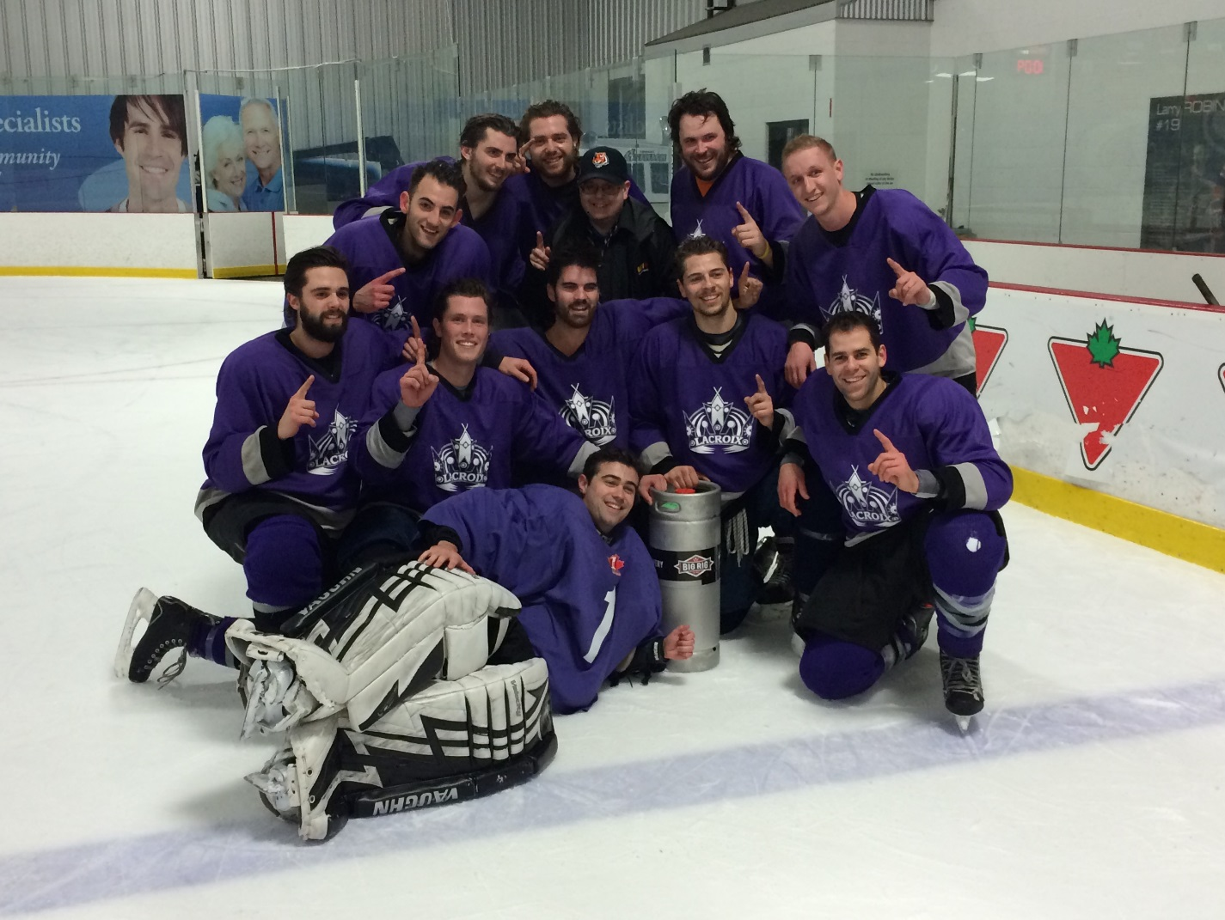

2018-2019 CRHL Winter Rules
“The Best in the West”

New for Winter 2018-2019 and FAQ
The CRHL is constantly trying to improve its product every season. Because of this, it is very important to know the changes going into the new season; however minor they may be. The following is a quick outline of changes introduced in the summer season, as well as some of the frequently asked questions.
a) Changes
- The CRHL will be discontinuing Pointstreak and will be shifting to HockeyShift
- The Exhibition season will be 2 games
- The CRHL no longer requires facial protection. Players without facial protection ARE NOT covered under insurance and are expected to know this.
- Play will be blown down immediately for high sticking the puck
- The CRHL will be taking a stricter stance on any penalties to the head

b) FAQ
How many games are required for a player to be eligible for playoffs?
(Section 5.c) A player must play at least 8 of 18 games to be eligible for the winter playoffs.
Does the whole team need matching jerseys?
(Section 3.c) Teams must have jerseys of matching colour with differentiating numbers after the 2 game exhibition period.
Can I play on two teams?
(Section 5.d) Yes.
Do I need to sign a waiver?
(Section 3.d) Yes, you can either print it out from the website and fill it out on your own time, or you can fill it out at the rink, the timekeepers will have some on hand.
One of my teammates got suspended but I don’t think it was the right call, how do I appeal it?
(Section 7) One game suspensions cannot be appealed. Multiple game suspensions can be appealed through an email to the Convenor. The CRHL reserves the right to dismiss appeals as they see fit.
Can I get a game rescheduled?
(Section 6.b) Yes, but the Convenor requires 2 weeks notice.
I have a player injured, can he still get credit for games he would have played in?
(Section 5.c) Yes, but the Convenor must be notified as soon as possible and prior to your next game. Last minute phantom injury requests will not be honoured.

Section 1 – Season Format
a) Exhibition Season and Regular Season
The CRHL winter season will consist of 2 exhibition games to start the season, 16 regular season games, and 4 guaranteed playoff games.
b) Alignment
The CRHL reserves the right to place teams in any division deemed appropriate at the beginning of the season, during the alignment phase at the end of the exhibition season, and during the mid-season alignment at the 5-game mark. Team Representative feedback is greatly encouraged in this area.
c) Ties in Standings
Final standings will be based on the winning percentage a team records for games played within their final division only. In the event of a tie in the standings after the regular season, final results will be decided by tiebreakers in the following order:
1. Highest Points
2. Most wins
3. Head to Head record between teams tied in Points
4. GF-GA
5. Lowest Goals Against
6. Lowest PIMS
Section 2 – Property & Safety
a) Alcohol
Alcoholic beverages and/or glass containers are prohibited in all arenas. Teams failing to adhere to this will face disciplinary action and bond forfeit, including possible team representative suspension.
Note: Bell Sensplex in Kanata and Richcraft Complex in Gloucester has obtained a license to sell beer in the dressing rooms. This license covers purchased alcohol, and does not allow teams to bring in their own alcohol for consumption
b) Smoking & Chewing Tobacco
Smoking or chewing tobacco is prohibited in all arenas. Teams failing to adhere to this will face disciplinary action, including possible team representative suspension. This rule applies to all areas within the facilities. Players of an offending team will, at a minimum, cause the team bond of $150.00 to be forfeited.
c) Property Damages
Any damage to the arena or its property must be paid for by the team responsible, prior to participation in any further League games. Non-compliance will constitute in automatic suspension from the League and further action as necessary. All players are expected to observe and follow building guidelines which are posted throughout the City of Ottawa complexes, Carleton Ice House, and Sensplex arenas, and/or communicated by staff of those facilities.
Note: Pre-game, all players (and pucks) must remain off the ice until such time that staff have fully completed their ice clean and the Zamboni doors have been shut. Post-game, all players are expected to leave the ice immediately without any delay for stretching, skating, speaking to officials, etc.
d) Personal Property
The CRHL accepts no responsibility for lost or stolen personal property. The League strongly recommends that no valuables be brought into the arena. Keys to lock dressing room doors can be acquired from the appropriate rink staff and it is the team's responsibility to lock their dressing room before going on the ice.
e) Accidents & Injuries
All accidents that affect a player’s ability to play in a League game, regardless of how the accident occurred, must be reported to the League manager immediately after the occurrence. Failure to do so may affect an injured player’s eligibility for playoffs even if the injured player is a regular on his team.
f) First Aid & Blood Drawn
The CRHL strongly encourages all teams and or participants to provide their own first aid supplies. All participants should also be aware of the closest pay phone in case of emergency or bring a cell phone to the bench. Heart defibrillator machines are located in most facilities. These machines are accessible to public, but please note that rink staff may not be trained to assist. Where possible, timekeepers and referees will attempt to assist in the event of an emergency. If a player is cut during a game and blood is drawn, the player must leave the ice to clean and bandage the wound prior to being allowed to continue playing in the game.
Section 3 – Administration
a) Notices
All players should check the League bulletin board (CRHL website) for any postings concerning rule amendments, standings and League news. Team representatives are encouraged to check in with the League office and communicate all concerns to the League manager. Please note that it is the responsibility of a team’s player representative to remain aware of all suspensions handed down by the League. These suspensions will appear on www.crhl.com and may be viewed by clicking on the Team’s Players Roster. Additionally, team representatives are subscribed to an email list at the start of the year. This is the convenor’s main method of communication; do not unsubscribe.
b) League Fees
Failure to meet the League payment schedule without contact to the convenor will result in immediate suspension of all team members until such time that the team account is brought into good standing. Payment options include credit card authorization, credit card payment through the online portal, cheques, and email transfer. All email transfers for account purposes are to be directed to convenor@crhl.com
c) Jerseys
All teams must have one full set of jerseys of matching colour and all players must be numbered differently and consistent with the gamesheet. Teams ordering new set(s) of jerseys should ensure they order enough jerseys to compensate for future spares. Teams will be given a grace period during the exhibition season and will be assigned a minor penalty during the regular season at the start of each game without matching colour jerseys. In the event of a conflict of team colors (the referees and timekeeper will determine if there is a conflict) the visiting team will wear the League jerseys, should neither team have a different coloured team jersey.
d) Waivers
Team representatives are responsible to have regular players sign the second portion of the Waiver handout. Spares must sign the single waiver handout that is posted on the website and timekeepers will have on hand. Once signed this can be given to a timekeeper. A player without a signed waiver will not step on the ice for a CRHL game.
e) Team Security Bond
Teams are required to deposit a $150 security bond that is refundable upon the end of the season. This security bond is due before the team’s first game. At the discretion of the CRHL, the bond may be revoked during the season for a number of reasons including:
- Fighting on or off the ice
- Forfeiting a scheduled league game with less than two days’ notice to the Convenor
- Causing damage to a facility
- Exhibiting repetitive disrespectful behavior to other teams, the league, the referees, or the timekeepers.

Section 4 – Equipment
a) Helmet and Facial Protection
C.S.A. approved helmets are mandatory and must be worn at all times by players and referees with properly fastened chinstraps. The CRHL no longer requires mandatory facial protection. All players who step onto the ice without facial protection waive their right to dental insurance.
b) Goaltender Equipment
Goaltenders may not wear homemade goalie masks nor “old school” goalie masks. All goalies must wear some sort of covering on the back of their legs for protection purposes: no bare legs. Failure to do so will result in a minor penalty for illegal equipment as well as a note to the convenor. The second offence and every additional offence will result in a penalty and goaltender suspension for an amount of games to be decided by the League. “Cat-eye” masks are allowed.
Section 5 – Rosters
a) Roster
Each team is permitted to carry a maximum of 22 players – including spare goaltender(s) – on their roster. Teams may be comprised of male or female hockey players.
b) Player Eligibility
Players arriving after the commencement of a game must immediately report to the timekeeper upon their arrival, and they must be on the ice prior to the start of the second period. Any player arriving after the start of the second period will not be allowed to play and will not receive credit for a game played. All players must be 19 years of age or older by the time playoffs start for insurance purposes and alcohol licensing.
c) Playoff Eligibility
To be eligible for playoff competition, a player must have played in 8 of his team's 18 games. All players who are checked on the official game sheet and who play before the start of the second period will receive credit for a game played. The only possible exception to this rule is in the case of player injury. If a player is expected to miss any length of games due to an injury the expected length of absence must be declared PRIOR to these games. League management may require medical verification as proof of a team’s claim. If a player representative approaches the League Manager at the conclusion of the season regarding an injury, consideration for credit towards playoff eligibility will not be granted.
While the League expects honesty from all player representatives when declaring their rosters, it has become an issue in the past where players are listed falsely on the game sheet to enhance playoff rosters. Players who show up late may automatically be required to provide ID to the timekeeper. In both instances, if a player is unable to provide valid ID (Driver’s Licence, Health Card, Student Card etc.) immediately upon request, he may cause his team to forfeit the game, for use of an illegal player and may also cause his team’s player representative to incur a suspension. Timekeepers have final authority on the matter of playoff eligibility.
d) Playing on Multiple Teams
If a player playing on multiple teams in different divisions is suspended, he must await the completion of the suspension with the team represented at the time of the infraction before returning to play on any team within any division of the CRHL.
e) Substitute Goaltenders
Substitute goaltenders of appropriate skill level may play in the regular season. If a goaltender is kicked out of a game by way of a gross misconduct, major or match, the team will be able replace the goalie or play with 6 players. Goalies will be permitted to continue play for the Game Ejection situation (3 minor penalties) or game misconduct, but will be suspended for his team’s next game. The goaltender may not participate on any team within any division of the CRHL until the suspension for his team’s next game has been served.
Should a goalie sustain an injury during the course of playing time and be unable to continue playing, the team with the injured goalie may dress a player and give that player goalie “rights”. Unlike Hockey Canada rules, the player granted goalie “rights” can rejoin as a player should a goalie from the next game present himself to play. The replacement goalie may be added to the team’s game roster and fill in for the remainder of the game.
f) Game Sheets
Game sheets and active players for each game must be registered between the timekeeper and each team’s player representative at least 5 minutes prior to warm-up. Please ensure accurate and honest line-ups. Referees and timekeepers will check numbers on the score sheet to ensure each team matches the score sheet line-up. Player representatives are to sign each game sheet.
Section 6 – Rules of Play
a) Defaulted Games
Teams are expected to be ready to play at the scheduled start time of their game. A minimum of 5 players and 1 goaltender are required to start a game. Any team unable to ice the proper number of players after the 2 minute warm-up will receive a minor penalty for delay of game. If the time clock runs down to 12 minutes and a team still does not have enough players, the game will then be defaulted. In the event of a defaulted game, the team with the required number of players will receive points for a 1 - 0 win. Defaulted games will not be re-scheduled.
b) Rescheduling Games
League Convenor requires a minimum of two weeks notice before the scheduled game in question in order to reschedule the game. An effort will be made to adhere to scheduling preferences at the start of the season but there is no guarantee the preferences will be perfectly reflected in each team’s respective schedule.
c) Timing of Game
Teams will be given a 2-minute warmup prior to the start of each game
Each game shall consist of two 22-minute straight time periods. In the event a game is within 2 goals in the final minute of play, the clock will run on stop time. Should the spread in goals be 3 or more in the final minute of play, the clock will run on straight time.
No time-outs are permitted in any CRHL game.
d) Games Tied at the End of Regulation
Each team will nominate 3 shooters, all of which have to be different. Players of both teams will shoot at the same time. The winning team will receive 2 Standings points, while the losing team in a shootout will receive 1 Standings point. If the game is still tied after 3 shooters, then the game ends in a tie. Both teams will receive one point if the game ends in a tie. Players with remaining penalty time at the end of a tied game are ineligible to shoot in the shootout.
e) Ice Gameplay Rules
All stoppages for icing will be initiated when the puck crosses the goal line of the non-offending team. All icing calls will be initiated by the offending team shooting the puck into the defending zone from behind the far blue line.
If a player’s skate(s) enters the goalie’s crease voluntarily in any manner, the referee has the discretion to blow down the play and a face-off will take place at the nearest spot in the neutral zone.
Contacting the puck with the stick above the normal height of the shoulders is not permitted. When this play is committed, play will be blown down immediately and play will be moved to the end of the team that committed the infraction.
There will not be a whistle when a puck strikes a goalie’s mask and the play will continue. Play will be stopped if the goalie’s mask is broken, has fallen off, or if the goalie appears injured.
f) Changing Players
Players will be allowed to change normally throughout the game when playing at even strength, shorthanded, and on the power play. All changes on stoppages of play must be completed as quickly as possible as referees have been instructed to use a “hurry-up” face-off procedure.
Section 7 – Suspensions
All infractions occurring before, during, and after any scheduled league game are subject to review by the CRHL. The League may assess suspensions at any time during the exhibition season, regular season, and playoffs.
a) Appeals
No appeal may be made on 1-game suspensions.
Team representatives are the only individuals who may appeal a suspension. Suspended players may not appeal their own suspension.
Any appeal must be received in writing (written, fax, or email). Appeals must be completed the day after the game, with a minimum 12 hour waiting period since the game was completed. Same-day appeals will not be reviewed.
b) Fighting
FIGHTING WILL RESULT IN A SEASON-ENDING SUSPENSION. Fighting has no place in adult recreational hockey. It is understood that should a player be deemed the instigator or aggressor of a fight and the opposing player engages in a fight for the sole purpose of protecting himself, the player deemed as exhibiting the instigating / aggressive action will receive the season-ending suspension. This rule does not target players who engage in single blows to the head, which would be penalized at the referee’s discretion. This is a recreational league; intimidation and revenge on the ice will not be tolerated. Any player used as a spare player who engages in a fight will cause the team to forfeit $150.00 off the Team Bond, and a 3-game suspension will be assessed against the offending team’s player representative.
c) Hallway Altercations
Any altercation in the hallway, or in dressing rooms between opposing teams or between players will result in a minimum 5-game suspension.
d) Engaging Referees
Any player engaging the referees in any manner after the conclusion of the game in the hallway, in their dressing room, or outside the arena may be suspended for the duration of the season. This interaction could include – but is not limited to – threatening language, verbal accosting or physical altercation.
e) Off-Ice Conduct
A player ejected from a game for any reason whatsoever must immediately proceed to his dressing room and may not enter his bench at any point. After changing into street clothes the player is to leave the building. If the individual fails to follow this rule or causes any disturbance whatsoever – through verbal abuse or otherwise – and prevents the game from continuing its regular flow, he / she will be subjected to a season-ending suspension.
f) Bonding Rule
Any player amassing certain penalty minute totals over the total 18 games of the winter exhibition and regular season will be subject to the following immediate suspensions:
45 PIM – immediate 1-game suspension
55 PIM – immediate 2-game suspension
70 PIM – immediate season-ending suspension

Section 8 – Penalties
Although not outlined below, elbowing, hooking, tripping, interference, holding, kneeing, unsportsmanlike conduct, and too many men penalties will be monitored based on the CHA Rule Book and standard hockey referee practices.
a) Penalty Substitutions
No player may serve another team member’s penalty except in the following situations:
- Penalty assessed to the goalie
- A major or match penalty that results in the removal of the original offending player
- A penalty to a player having been ejected from the game for 3 penalties
- A penalty assessed to a player that had to leave the ice due to injury
In all situations, the player serving must be on the ice at the time of the infraction
b) Length of Penalties
Minor – 3 minutes
Major – 7 minutes
Match – 7 minutes
Misconduct – 10 minutes in time penalties
Game Misconduct – 10 minutes in time penalties & ejection
Game Ejection – ejection
Gross Misconduct – 10 minutes in time penalties & ejection
c) Game Ejection
Any player receiving three (3) minor penalties or two (2) 10-minute misconduct penalties in one game will receive a game ejection penalty. Such an infraction shall not carry any suspension unless the last penalty is a game misconduct. If a goaltender receives a game ejection for penalties, he will be allowed to remain in the game but will be suspended for his team’s next scheduled game. The goaltender may not participate on any team within any division of the CRHL until the suspension for his team’s next game has been served. Teams and players that are repeat offenders of these situations may face supplementary discipline from the League. There will be no additional PIM assessed for Game Ejection penalties.
d) Trash Talking, Racial or Ethnic Comments
If a player, timekeeper, or referee overhears verbal accosting in this nature, the League will investigate the incident and may impose suspensions and / or a lifetime ban to the offending player. Such comments include (but are not necessarily limited to slurs of racism, sexual preference, ethnic or religious beliefs, and spoken languages.
Referees can assess a minor, major, match, misconduct, game misconduct, game ejection, or gross misconduct penalty based on the severity of the verbal comments. Abuse towards referees, other players, timekeepers, or arena staff will not be tolerated.
e) Head Contact
There is no specific “head contact” penalty in the CRHL; however, if minor penalty is committed to an opponent’s head it is a double minor, major, or match at the referee’s discretion.
f) High Sticking
A player who contacts an opponent above the normal height of his shoulders with a high stick shall be assessed a minor, double-minor, major, or match penalty at the discretion of the referee. If an injury results, blood has been drawn, or the referee deems it necessary based on severity, a major penalty or match penalty will be assessed.
g) Body Contact, Boarding & Charging
Deliberate body contact is not permitted anywhere on the ice. Any collisions or contact will be strictly a referee judgment call based on the following definition of contact: No player is entitled to use his body to intentionally body-check or bump an opponent. A minor, Major and Game Misconduct or Match penalty at the discretion of the referee, shall be assessed to any player who body checks, boards or charges an opponent.
h) Butt-Ending
A double-minor, or Match penalty will be assessed to any player who butt-ends, or attempts to butt-end an opponent. Hooking a player with the butt-end of the stick will normally be assessed as a double minor. Intent will be the determining factor for the length of penalty. The call will be made at the discretion of the referee.
i) Roughing
A minor, double-minor or Major penalty and Game Misconduct shall be assessed to any player who, in the referee's judgment, is guilty of unnecessary rough play. The League manager may, at their own discretion, choose to monitor and review any player whose rough play is deemed to be potentially detrimental to the League. Any review may result in suspension from play. Blows to the head after the play has been blown dead are not tolerated; referees are requested to enforce such actions diligently. In situations in which blows to the head happen after the whistle referees are to assess Misconduct (when minors are involved).
j) Spearing
A double-minor, or Match penalty shall be assessed to any player who pokes or jabs or attempts to jab an opposing player with the toe of the blade of his stick. A match penalty shall be assessed to any player who deliberately spears or deliberately attempts to spear by jabbing forcefully with the toe of the blade of his stick or who injures an opponent by any spearing.
k) Slashing
A slashing penalty shall be assessed to any player who swings his stick at an opponent (whether out of range or not) without actually striking him, or who, on the pretext of playing the puck, makes a wild swing at the puck with the object of intimidating his opponent. A minor, Major and Game Misconduct or Match penalty, at the discretion of the referee, shall be assessed to any player who impedes or seeks to impede the progress of an opponent by slashing with a stick.
l) Cross-Checking
A minor, Major and Game Misconduct or Match penalty at the discretion of the referee, shall be assessed to any player who cross-checks an opponent. A minimum of a major penalty and game misconduct penalty shall be assessed to any player who injures an opponent as a result of a cross-check.
m) Slew-Footing or Checking from Behind
There will be an automatic game misconduct for any player penalized with a slough-footing or checking from behind penalty during a game. A double-minor, Major and Game Misconduct penalty or Match penalty at the discretion of the referee shall be assessed to any player who injures an opponent. Any player assessed a Checking from Behind minor or double minor shall immediately be assessed a Game Misconduct. Any player that persists in committing these infractions may face further discipline from the League.
n) Attempt to Injure
An attempt to injure, in the opinion of the referee, is an automatic match penalty regardless of whether it causes injury or not, and will be reviewed by the League manager. The pending results of the injury will be considered by the League manager, when determining if additional discipline is necessary.

